创建lambda函数访问：
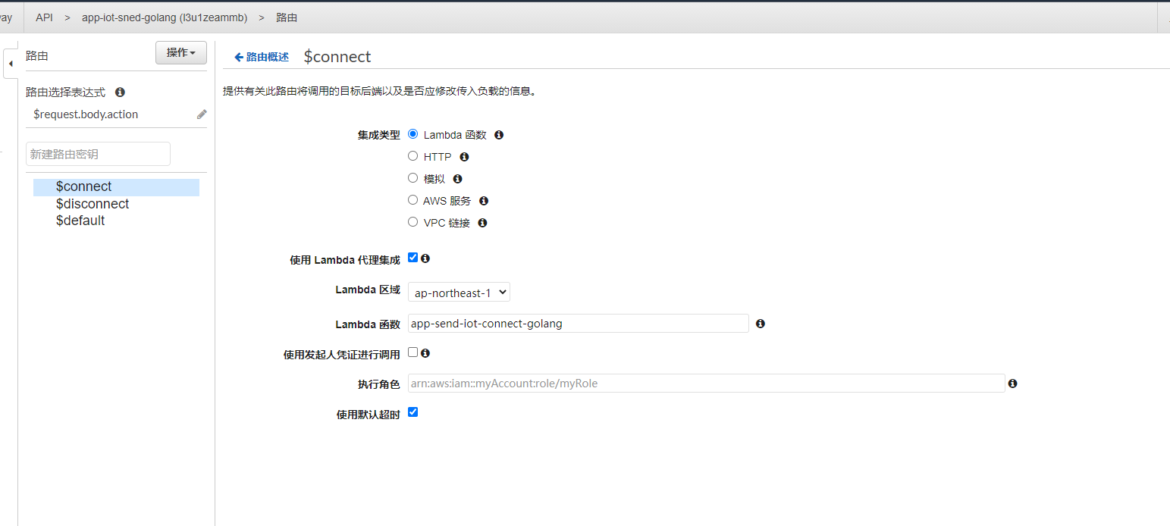

需要重新部署api
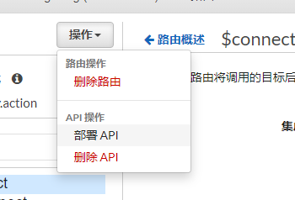

如果需要配置iam授权：
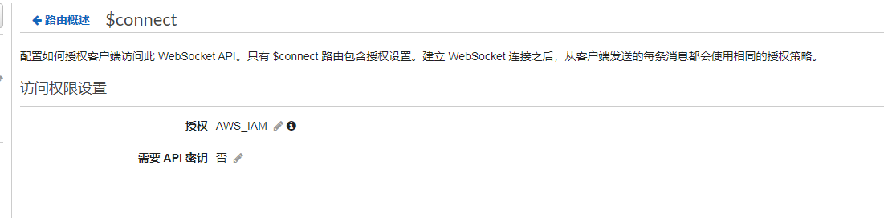

针对于iam身份授权的权限json：
{
"Version": "2012-10-17",
"Statement": [
{
"Sid": "VisualEditor0",
"Effect": "Allow",
"Action": "execute-api:Invoke",
"Resource": "arn:aws:execute-api:ap-northeast-1:421169849825:l3u1zeammb/*/$connect"
}
]
}

resource填写connect路由的arn

如下PDB添加：
https://console.aws.amazon.com/iam/home#/policies/arn:aws:iam::421169849825:policy/apigateway_post$jsonEditor
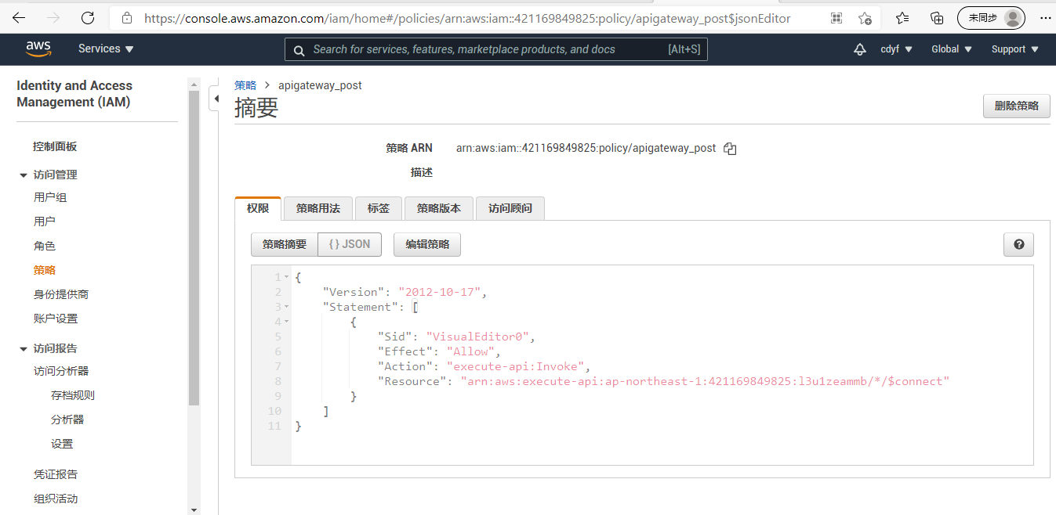

API Gateway访问秘钥
https://console.aws.amazon.com/iam/home#/users/api-gateway-post?section=security_credentials
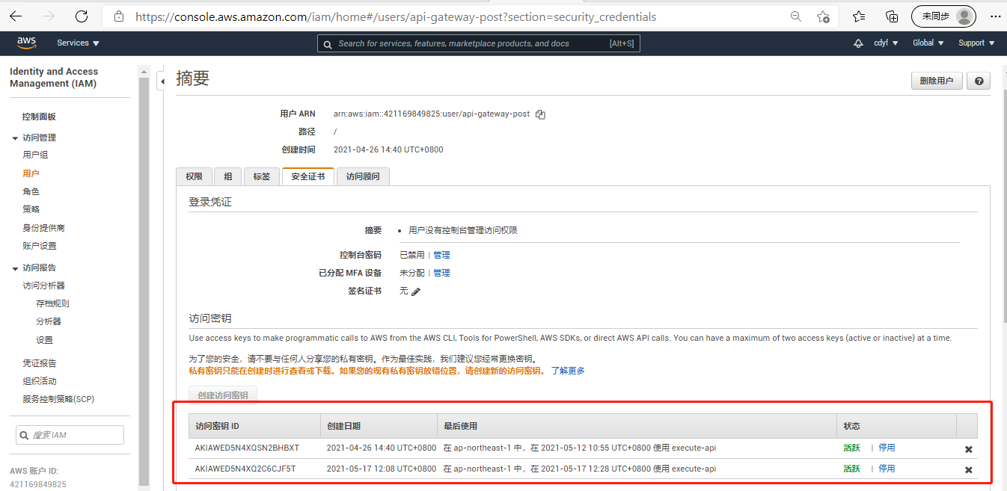
wss地址查看
